**Online Meeting Media**

**SOFTWARE REQUIREMENT SPECIFICATIONS**

**Introduction**

Communication is very much essential and the importance of it is increasing from time to time along with the evolution of human needs. Developing Online Meeting for an Organization.

The main concept of Online Meeting is developing the conference on the net. We can compare the Online Meeting with the Telephone Conference. Normally in Telephone Conference, there will be more than two users connected at a time and all the users are able to here words from any one of the user. So implementing the same concept on the Net is nothing but Online Meeting.

**Purpose:**

The purpose of this Software Requirement Specification (SRS) is to help the project.

This project is used to Conduct conferences with their employees. So they can get online decisions from employees from the different branches of the company.

**Scope:**

Communication is very much essential and the importance of it is increasing from time to time along with the evolution of human needs. Developing Online Meeting for an Organization.

## Definitions, Acronyms and Abbreviations:

* SLA: Service Level Agreement or SLA is a formal written agreement made between two parties, the service provider & the service recipient. It defines the term of engagement - the fundamental rules that will govern the relationship.
* **JAVA:** Java is a internet software which is used to develop distributed /web applications and It's also integral to the intranet applications and other e-business solutions that are the foundation of corporate computing.
* **Database(Oracle 10g):**database is a collection of [information](http://whatis.techtarget.com/definition/0,289893,sid9_gci212343,00.html) that is organized so that it can easily be accessed, managed and updated.
* **Apache Tomcat server: Apache Tomcat:** is an [open source](http://en.wikipedia.org/wiki/Open_source) [servlet container](http://en.wikipedia.org/wiki/Java_Servlet#Servlet_containers) developed by the [Apache Software Foundation](http://en.wikipedia.org/wiki/Apache_Software_Foundation) (ASF). Tomcat implements the [Java Servlet](http://en.wikipedia.org/wiki/Java_Servlet) and the [JavaServer Pages](http://en.wikipedia.org/wiki/JavaServer_Pages) (JSP) specifications from [Sun Microsystems](http://en.wikipedia.org/wiki/Sun_Microsystems) and provides a "pure [Java](http://en.wikipedia.org/wiki/Java_%28programming_language%29)" [HTTP](http://en.wikipedia.org/wiki/Hypertext_Transfer_Protocol) [web server](http://en.wikipedia.org/wiki/Web_server) environment for [Java](http://en.wikipedia.org/wiki/Java_%28programming_language%29) code to run.
* HTTP: Hypertext Transfer Protocol is a transaction oriented client/server protocol between a web browser & a Web Server.
* HTTPS: Secure Hypertext Transfer Protocol is a HTTP over SSL (Secure Socket Layer).
* TCP/IP: Transmission Control Protocol/Internet Protocol, the suite of communication protocols used to connect hosts on the Internet. TCP/IP uses several protocols, the two main ones being TCP and IP.
* **XML:** Extensible Mark-up Language. The Extensible Markup Language (**XML**) is a general-purpose specification for creating custom markup languages.
* **AJAX: AJAX** (Asynchronous JavaScript and XML), is a group of interrelated web development techniques used to create interactive web applications or rich Internet applications. With Ajax, web applications can retrieve data from the server asynchronously in the background without interfering with the display and behavior of the existing page.
* **SRS:** Software Requirement Specification.

**Reference:**

* IEEE Standard Format for SRS.
* XML 1.1 Bible
* http://[www.sun.com](http://www.sun.com)
* http://www.oracle.com/technetwork/java/index.html

## Technologies to be used:

* Programming languages:
* JAVA: java technology is a high-level programming and a platform independent language. Java is designed to work in the distributed environment on the Internet.
* HTML, XML: Hyper Text Markup Language and Extensible markup Language are the predominant markup languages for web pages. It provides a means to describe the structure of text-based information in a document and to supplement that text with interactive forms, embedded images, and other objects.
* JavaScript: A client side scripting language used to create dynamic web content and user interface.
* Tools & Development Environment:
* **Servers:** Operating System Server: - Microsoft Windows XP/2000
* **Data Base Server**: ORACLE 10g
* **Clients:** Anyweb browser
* **Development Tools:** JAVA
* **Documentation Tools:** MS Office 2003/2007
* **Drawing Tools:** IBM Rational Rose Enterprise, MS Office Visio 2007
* **User Interface:** HTML WITH JAVA SCRIPT
* **Code Behind:** JSE,JEE

**Software Interface:**

* **Client on Internet/Intranet:** Web Browser.
* **Web Server:** Apache Tomcat.
* **Database Server:** Oracle10g
* **Development End:** Net Beans 6.8

**Hardware Requirements:**

|  |  |  |  |
| --- | --- | --- | --- |
| **Client Side** | | | |
|  | **Processor** | **RAM** | **Disk Space** |
| **Any browser**  **Or Higher** | Computer with a 2.6GHz processor or higher (Pentium processor recommended) | 512MB Minimum | Minimum 20 GB |
| **Server Side** | | | |
| **Apache Tomcat** | Intel Pentium processor at 2.6GHz or faster | Minimum 512 MB Physical Memory; 1 GB Recommended | Minimum 20 GB |
| **Net Beans 6.8**  **Oracle10g** | Intel Pentium Processor at  2.6GHz or faster | Minimum 512 MB Physical Memory; (1 GB Recommended) | Minimum 20 GB |

**Communication Interface:**

* Access of the CMS through Internet will be using HTTP/HTTPS protocol.
* Access of the CMS within Local Network will be using TCP/IP Protocol.

**Overview:**

This project will be designed and developed for Communication between various departments on various topics. We can compare the *Online Meeting* with the *Telephone Conference*. Normally in *Telephone Conference*, there will be more than two users connected at a time and all the users are able to here words from any one of the user. So implementing the same concept on the Net is nothing but *Online Meeting*.

The database system must provide for the safety of the information stored, despite system crashes or attempts at unauthorized access. If data are to be shared among several users, the system must avoid possible anomalous results.

**Existing System:**

The existing system is manual and the manual system works in the following way:

* Conferences will take part a vital role for any of the national wide company.
* A company like National Engineering Corporation it takes parts an important role.
* Because
* the company is having branches throughout India, they need to conduct Conference between their employees and to conduct board of directors meeting among their directors, general managers.

Normally conferences will be conducted in some place owned by company or in some conference hall. The person, who has to participate in the conference, has to travel all the way to participate in the conference. So it will be very risky to travel for the persons, and it is risky work for the company also to provide all the felicities to persons. Now a day wherever you see so many strikes are going. In that case to participate in any important conference or to conduct any conference will be very tedious. All this may lead to loss of company and time taking matters. So here the company is decided to develop their conferences on the net itself

**Proposed System:**

The proposed system is to maintain the conferences, live meetings, general body meetings on the net. This system is to develop in a client/server environment. It aims to do the following.

* Grouping: Grouping of selected users
* Support of multi conference
* By selecting the single user from the list, **Talk** can be achieved

By selecting all the users in the list, **Chat** can be achieved

**Functional Requirements of the project:**

The main concept of Online Meeting is developing the conference on the net. We can compare the *Online Meeting* with the *Telephone Conference*. Normally in *Telephone Conference*, there will be more than two users connected at a time and all the users are able to here words from any one of the user. So implementing the same concept on the Net is nothing but *Online Meeting*.

This project is used to:

* Conduct conferences with their employees. So they can get online decisions from employees from the different branches of the company.
* Another advantage is that the company is having branches throughout the country. So this will help them to communicate business affairs of the company and live meetings and conferences between their directors. They can conduct board of directors meeting.
* It will give On-line solutions from the superiors to the employees.

# Non-Functional Requirements:

The system should be web-based system. Users should use the system via internet. Each user should have a user account. The system should ask the username and password to users. It doesn’t permit to unregistered user to access for Insurance on Internet. The system should have Role based System functions access. Approval Process has to be defined. The system should have Modular customization components so that they can be reused across the implementation.

These are the mainly following:

* 24 X 7 availability
* Better component design to get better performance at peak time
* Flexible service based architecture will be highly desirable for future extension.

# Study of the System:

To provide flexibility to the users, the interfaces have been developed that are accessible through a browser. The GUI’S at the top level have been categorized as

1. Administrative user interface
2. The operational or generic user interface

The ‘operational or generic user interface’ helps the end users of the system in transactions through the existing data and required services. The operational user interface also helps the ordinary users in managing their own information in a customized manner as per the included flexibilities.

# Number of Modules:

**Admin Features:**

* Create Edit, and Delete Conference Rooms.
* Create, Edit, and Delete Users.
* Moderator Privileges.
* View and Delete Message Archives.
* View Statistics.
* Ban Users.

**Client Features:**

* User Registration
* Private Messaging
* Create Room
* Moderator
* Lists all Users in Conference Room
* View profiles

**SDLC METHODOLOGIES:**

This document play a vital role in the development of life cycle (SDLC) as it describes the complete requirement of the system. It means for use by developers and will be the basic during testing phase. Any changes made to the requirements in the future will have to go through formal change approval process.

SPIRAL MODEL was defined by Barry Boehm in his 1988 article, “A spiral Model of Software Development and Enhancement. This model was not the first model to discuss iterative development, but it was the first model to explain why the iteration models.

As originally envisioned, the iterations were typically 6 months to 2 years long. Each phase starts with a design goal and ends with a client reviewing the progress thus far. Analysis and engineering efforts are applied at each phase of the project, with an eye toward the end goal of the project.

The steps for Spiral Model can be generalized as follows:

The new system requirements are defined in as much details as possible. This usually involves interviewing a number of users representing all the external or internal users and other aspects of the existing system.

A preliminary design is created for the new system.

A first prototype of the new system is constructed from the preliminary design. This is usually a scaled-down system, and represents an approximation of the characteristics of the final product.

A second prototype is evolved by a fourfold procedure:

Evaluating the first prototype in terms of its strengths, weakness, and risks.

Defining the requirements of the second prototype.

Planning a designing the second prototype.

Constructing and testing the second prototype.

At the customer option, the entire project can be aborted if the risk is deemed too great. Risk factors might involve development cost overruns, operating-cost miscalculation, or any other factor that could, in the customer’s judgment, result in a less-than-satisfactory final product.

* The existing prototype is evaluated in the same manner as was the previous prototype, and if necessary, another prototype is developed from it according to the fourfold procedure outlined above.
* The preceding steps are iterated until the customer is satisfied that the refined prototype represents the final product desired.
* The final system is constructed, based on the refined prototype.
* The final system is thoroughly evaluated and tested. Routine maintenance is carried on a continuing basis to prevent large scale failures and to minimize down time

**The following diagram shows how a spiral model acts like:**

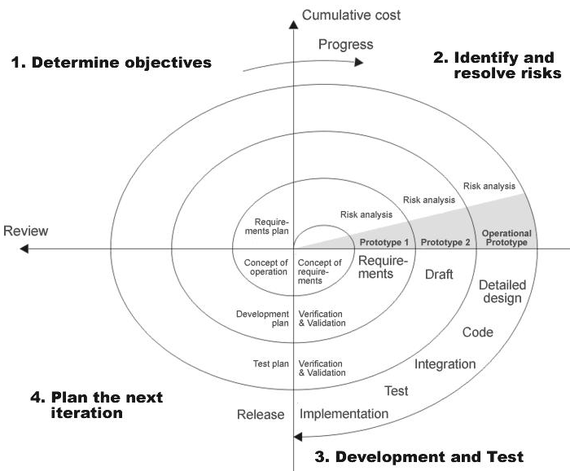

**Fig 1.0: Spiral Model**

The developer is responsible for:

* Developing the system, this meets the SRS and solving all the requirements of the system.
* Demonstrating the system and installing the system at client's location after the acceptance testing is successful.
* Submitting the required user manual describing the system interfaces to work on it and also the documents of the system.
* Conducting any user training that might be needed for using the system.
* Maintaining the system for a period of one year after installation.

**INPUT DESIGN:**

Input design is a part of overall system design. The main objective during the input design is as given below:

* To produce a cost-effective method of input.
* To achieve the highest possible level of accuracy.
* To ensure that the input is acceptable and understood by the user.

**INPUT STAGES:**

The main input stages can be listed as below:

* Data recording
* Data transcription
* Data conversion
* Data verification
* Data control
* Data transmission
* Data validation
* Data correction

**INPUT TYPES:**

It is necessary to determine the various types of inputs. Inputs can be categorized as follows:

* External inputs, which are prime inputs for the system.
* Internal inputs, which are user communications with the system.
* Operational, which are computer department’s communications to the system?
* Interactive, which are inputs entered during a dialogue.

**INPUT MEDIA:**

At this stage choice has to be made about the input media. To conclude about the input media consideration has to be given following:

* Type of input
* Flexibility of format
* Speed
* Accuracy
* Verification methods
* Rejection rates
* Ease of correction
* Storage and handling requirements
* Security
* Easy to use
* Portability

Keeping in view the above description of the input types and input media, it can be said that most of the inputs are of the form of internal and interactive. As Input data is to be the directly keyed in by the user, the keyboard can be considered to be the most suitable input device.

**OUTPUT DESIGN:**

Outputs from computer systems are required primarily to communicate the results of processing to users. They are also used to provide a permanent copy of the results for later consultation. The various types of outputs in general are:

* External Outputs, whose destination is outside the organization
* Internal Outputs whose destination is within organization and they are the
  + - User’s main interface with the computer.
* Operational outputs whose use is purely within the computer department.
* Interface outputs, which involve the user in communicating directly with

**OUTPUT DEFINITION:**

The outputs should be defined in terms of the following points:

* + - Type of the output
    - Content of the output
    - Format of the output
    - Location of the output
    - Frequency of the output
    - Volume of the output
    - Sequence of the output

It is not always desirable to print or display data as it is held on a computer. It should be decided as which form of the output is the most suitable.

For Example:

* Will decimal points need to be inserted
* Should leading zeros be suppressed.

**OUTPUT MEDIA:**

In the next stage it is to be decided that which medium is the most appropriate for the output. The main considerations when deciding about the output media are:

* The suitability for the device to the particular application.
* The need for a hard copy.
* The response time required.
* The location of the users
* The software and hardware available.

Keeping in view the above description the project is to have outputs mainly coming under the category of internal outputs. The main outputs desired according to the requirement specification are:

The outputs were needed to be generated as a hot copy and as well as queries to be viewed on the screen. Keeping in view these outputs, the format for the output is taken from the outputs, which are currently being obtained after manual processing. The standard printer is to be used as output media for hard copies.

**CONTEXT DIAGRAM: (0 Levels DFD)**



**APPLICATION DEVELOPMENT ARCHITECTURE:** To develop an application we use N-Tier Architecture.

**N-Tier** **Architecture:**

Can easily implement the concepts of Distributed Application Design and Architecture. The N-Tier Architecture provides strategic benefits to Enterprise Solutions. While 2-tier, client-server can help us create quick and easy solutions and may be used for Rapid Prototyping, they can easily become a maintenance and security night mare

The N-tier Applications provide specific advantages that are vital to the business continuity of the enterprise. Typical features of a real life n-tier may include the following:

* Security
* Availability and Scalability
* Manageability
* Easy Maintenance
* Data Abstraction

The above mentioned points are some of the key design goals of a successful n-tier application that intends to provide a good Business Solution.

**Definition:**

Simply stated, an n-tier application helps us distribute the overall functionality into various tiers or layers:

* Presentation Layer
* Business Rules Layer
* Data Access Layer
* Database/Data Store

Each layer can be developed independently of the other provided that it adheres to the standards and communicates with the other layers as per the specifications.

This is the one of the biggest advantages of the n-tier application. Each layer can potentially treat the other layer as a ‘Block-Box’.

In other words, each layer does not care how other layer processes the data as long as it sends the right data in a correct format.

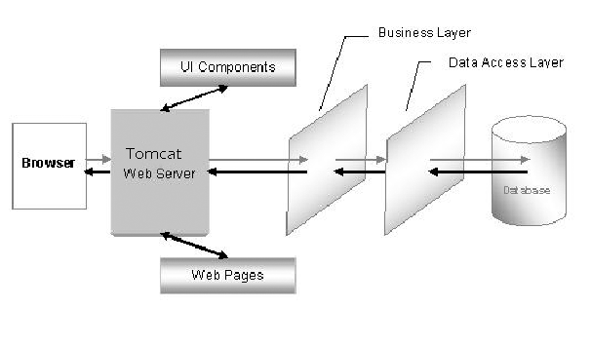

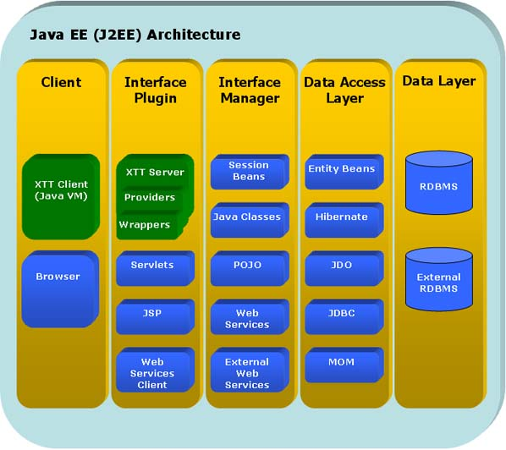

**Fig -N-Tier Architecture**

1. **The Presentation Layer:**

It is also called as the client layer comprises of components that are dedicated to presenting the data to the user. For example: Windows/Web Forms and buttons, edit boxes, Text boxes, labels, grids, etc.

1. **The Business Logic Layer:**

This layer encapsulates the Business rules or the business logic of the encapsulations. To have a separate layer for business logic is of a great advantage. This is because any changes in Business Rules can be easily handled in this layer. As long as the interface between the layers remains the same, any changes to the functionality / processing logic in this layer can be made without impacting the others. A lot of client-server apps failed to implement successfully as changing the business logic was a painful process.

1. **The Data Access Layer:**

This layer comprises of components that help in accessing the Database. If used in the right way, this layer provides a level of abstraction for the database structures. Simply put changes made to the database, tables, etc do not affect the rest of the application because of the Data Access layer. The different application layers send the data requests to this layer and receive the response from this layer.

1. **The Database Layer:**

This layer comprises of the Database Components such as DB Files, Tables, Views, etc. The Actual database could be created using SQL Server, Oracle, Flat files, etc. In an n-tier application, the entire application can be implemented in such a way that it is independent of the actual Database. For instance, you could change the Database Location with minimal changes to Data Access Layer. The rest of the Application should remain unaffected

**PERFORMANCE REQUIREMENTS:**

Performance is measured in terms of the output provided by the application. Requirement specification plays an important part in the analysis of a system. Only when the requirement specifications are properly given, it is possible to design a system, which will fit into required environment. It rests largely in the part of the users of the existing system to give the requirement specifications because they are the people who finally use the system. This is because the requirements have to be known during the initial stages so that the system can be designed according to those requirements. It is very difficult to change the system once it has been designed and on the other hand designing a system, which does not cater to the requirements of the user, is of no use.

The requirement specification for any system can be broadly stated as given below:

* The system should be able to interface with the existing system
* The system should be accurate
* The system should be better than the existing system

The existing system is completely dependent on the user to perform all the duties.

**FEASIBILITY REPORT:**

Preliminary investigation examine project feasibility, the likelihood the system will be useful to the organization. The main objective of the feasibility study is to test the Technical, Operational and Economical feasibility for adding new modules and debugging old running system. All system is feasible if they are unlimited resources and infinite time. There are aspects in the feasibility study portion of the preliminary investigation:

* Technical Feasibility
* Operation Feasibility
* Economical Feasibility

**Technical Feasibility**

The technical issue usually raised during the feasibility stage of the investigation includes the following:

* Does the necessary technology exist to do what is suggested?
* Do the proposed equipments have the technical capacity to hold the data required to use the new system?
* Will the proposed system provide adequate response to inquiries, regardless of the number or location of users?
* Can the system be upgraded if developed?
* Are there technical guarantees of accuracy, reliability, ease of access and data security?

Earlier no system existed to cater to the needs of ‘Secure Infrastructure Implementation System’. The current system developed is technically feasible. It is a web based user interface for Online Project Management. Thus it provides an easy access to the users. The database’s purpose is to create, establish and maintain a workflow among various entities in order to facilitate all concerned users in their various capacities or roles. Permission to the users would be granted based on the roles specified. Therefore, it provides the technical guarantee of accuracy, reliability and security. The software and hard requirements for the development of this project are not many and are already available in-house or are available as free as open source. The work for the project is done with the current equipment and existing software technology. Necessary bandwidth exists for providing a fast feedback to the users irrespective of the number of users using the system.

**Operational Feasibility**

Proposed projects are beneficial only if they can be turned out into information system. That will meet the organization’s operating requirements. Operational feasibility aspects of the project are to be taken as an important part of the project implementation. Some of the important issues raised are to test the operational feasibility of a project includes the following: -

* Is there sufficient support for the management from the users?
* Will the system be used and work properly if it is being developed and implemented?
* Will there be any resistance from the user that will undermine the possible application benefits?

This system is targeted to be in accordance with the above-mentioned issues. Beforehand, the management issues and user requirements have been taken into consideration. So there is no question of resistance from the users that can undermine the possible application benefits.

The well-planned design would ensure the optimal utilization of the computer resources and would help in the improvement of performance status.

**Economic Feasibility**

A system can be developed technically and that will be used if installed must still be a good investment for the organization. In the economical feasibility, the development cost in creating the system is evaluated against the ultimate benefit derived from the new systems. Financial benefits must equal or exceed the costs. The system is economically feasible. It does not require any addition hardware or software. Since the interface for this system is developed using the existing resources and technologies available at NIC, There is nominal expenditure and economical feasibility for certain.